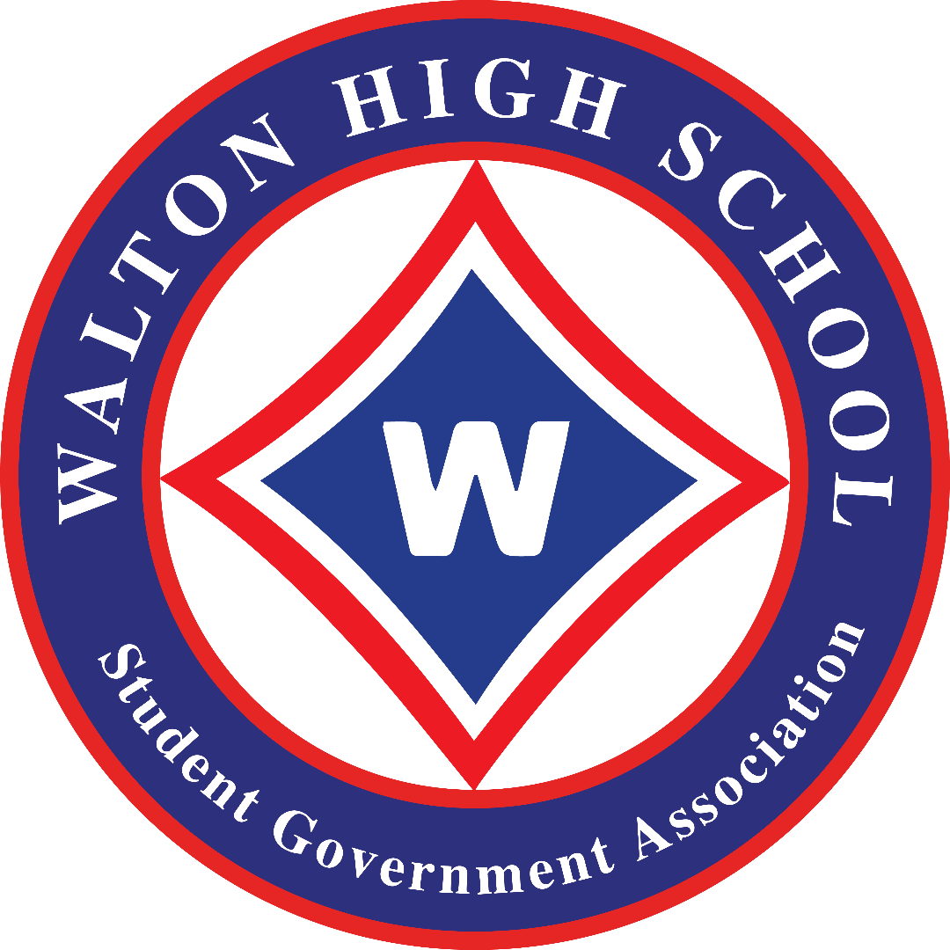
RESOLUTION
Resolution Condemning Anti-Semitism and Other Discrimination

WHEREAS, The Student Government Association, the Students of Walton High School, the Walton High School Faculty and Administration, and surrounding community leaders, are deeply saddened by the heartbreaking events that have occurred across the country and in our communities and schools in relation to anti-Semitism and other discrimination; and

WHEREAS, Anti-Semitism, racism, and other forms of discrimination have no place at Walton High School or in our school community. Any and all behavior relating to anti-Semitism, racism, or any other type of discrimination is not tolerated at Walton High School or towards its school community; and

REITERATING, Walton High School and its school community act as an inclusive and open environment for every student, parent, teacher, member, and representative. Every representative of Walton High School will act to promote equality throughout the school community and within the education system. The environment of Walton High School will maintain and continue to promote the Constitutional rights of every person visiting, working, or learning as a part of Walton and its community; and

WHEREAS, The citizens of Walton High School and its school community appreciate the support from its students, parents, faculty, members, and representatives in promoting equality, fairness, and honesty. The support and endorsement from surrounding religious and ethnic leaders further bolsters the equality throughout Walton’s community; and

RESOLVED, The Student Government Association, paralleled with the Walton High School Faculty and School Community, will stand with all citizens and members of the school community against anti-Semitism, racism, and all accompanying forms of discrimination. We will continue our commitment to maintaining an equal environment for all citizens of Walton High School and support a setting of equal religious rights, equal racial rights, equal cultural rights, and equal civil rights for all.

Approved: 13th of December 2021

